**Experiments on Symmetric - Key Cryptography Principles**

**ISA (Information Security Assurance) 562**

**Project Report**

**Team Members:**

Mihul Singh (G01373835) – Task 1, Task 2, and Task 3

Ramaswamy Iyappan (G01348097) – Initial Setup, Task 4, and Task 5

**Project Overview:**

This project focuses on various aspects of cryptography and encryption. It involves tasks related to frequency analysis, text decryption, encryption using different ciphers and modes, encryption mode comparison, padding schemes, and error propagation analysis. Each task contributes to a comprehensive understanding of cryptographic techniques and their applications.

**Task 1: Frequency Analysis**

Step 1: Frequency Analysis

Analysed the frequency of n-grams in a given ciphertext using a Python script.

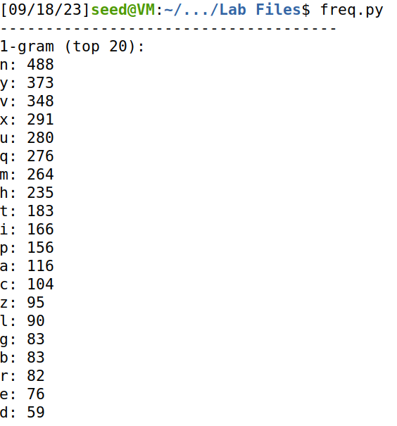

Here we identify the most common letters, letter pairs, and letter triplets in the ciphertext.

Step 2: We start by identifying common letters, the letters 'ytn' appear quite frequently, so it is a good candidate for the word 'THE' in English, we replace 'ytn' with 'THE' using the tr command.

*Command:* tr 'ytn' 'THE' < ciphertext.txt > decrypted1.txt

Step 3: Replacing 'THvT' with 'THAT'.

*Command:* tr 'THvT' 'THAT' < decrypted1.txt > decrypted2.txt

Step 4: Since 'AhE' seems like 'ARE', replace 'h' with 'R'.

*Command:* tr 'h' 'R' < decrypted2.txt > decrypted3.txt

Step 5: The phrase 'lHETHER' seems like 'WHETHER'. Replace 'l' with 'W'.

*Command:* tr 'l' 'W' < decrypted3.txt > decrypted4.txt

Step 6: Since 'THEmR' and 'mT' seem like 'THEIR' and 'IT'. Replace 'm' with 'I'.

*Command:* tr 'm' 'I' < decrypted4.txt > decrypted5.txt

Step 7: Since 'THIq' seems like 'THIS'. Replace 'q' with 'S'.

*Command:* tr 'q' 'S' < decrypted5.txt > decrypted6.txt

Step 8: Phrase 'bIRST' seems like 'FIRST'. Replace 'b' with 'F'.

*Command:* tr 'b' 'F' < decrypted6.txt > decrypted7.txt

Step 9: Since 'AWARpS' seems like 'AWARDS'. Replace 'p' with 'D'.

*Command:* tr 'p' 'D' < decrypted7.txt > decrypted8.txt

Step 10: 'AuxTHER FEATzRE xF' seems like 'ANOTHER FEATURE OF'. Replace 'ux' with 'NO', 'z' with 'U' and 'x' with 'O'.

*Commands:*

tr 'ux' 'NO' < decrypted8.txt > decrypted9.txt

tr 'z' 'U' < decrypted9.txt > decrypted10.txt

tr 'x' 'O' < decrypted10.txt > decrypted11.txt

Step 11:

REAiid can be REALLY

sNOWS can be KNOWS

rOINr can be GOING

EDUaATED can be EDUCATED

*Commands:*

tr 'i' 'L' < decrypted11.txt > decrypted12.txt

tr 's' 'K' < decrypted12.txt > decrypted13.txt

tr 'r' 'G' < decrypted13.txt > decrypted14.txt

tr 'a' 'C' < decrypted14.txt > decrypted15.txt

Step 12:

gIG -> BIG

jUESTION -> QUESTION

ACADEcd -> ACADEMY

*Commands:*

tr 'g' 'B' < decrypted15.txt > decrypted16.txt

tr 'j' 'Q' < decrypted16.txt > decrypted17.txt

tr 'c' 'M' < decrypted17.txt > decrypted18.txt

tr 'd' 'Y' < decrypted18.txt > decrypted19.txt

Step 13:

eICTURE -> PICTURE

FAfORITE -> FAVORITE

EkTRA -> EXTRA

*Commands:*

tr 'e' 'P' < decrypted19.txt > decrypted20.txt

tr 'f' 'V' < decrypted20.txt > decrypted21.txt

tr 'k' 'X' < decrypted21.txt > decrypted22.txt

Step 14:

w -> Z

o -> J

*Commands:*

tr 'w' 'Z' < decrypted22.txt > decrypted23.txt

tr 'o' 'J' < decrypted23.txt > decrypted24.txt

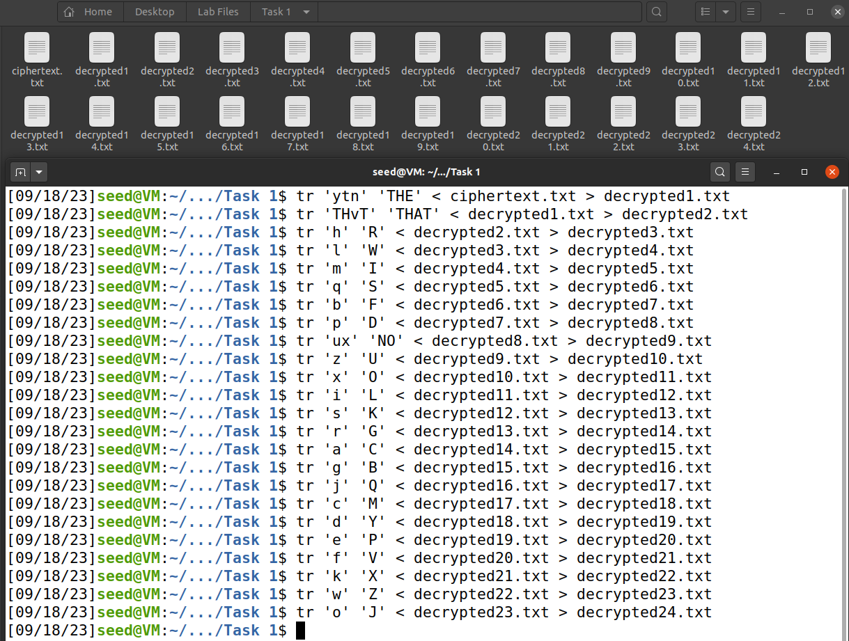

*Final command to decrypt the entire text:*

tr 'vgapnbrtmosicuxejhqyzflkdw' 'ABCDEFGHIJKLMNOPQRSTUVWXYZ' < ciphertext.txt > decryptedtext.txt

**Task 2: Encryption using Different Ciphers and Modes**

**Encryption 1: AES-128-CBC**

*Encryption Command:*

openssl enc -aes-128-cbc -e -in decryptedtext.txt -out ciphertext_aes-128-cbc.txt -K 00112233445566778889aabbccddeeff -iv 0102030405060708

*Decryption Command:*

openssl enc -aes-128-cbc -d -in ciphertext_aes-128-cbc.txt -out decryptedtext_aes-128-cbc.txt -K 00112233445566778889aabbccddeeff -iv 0102030405060708

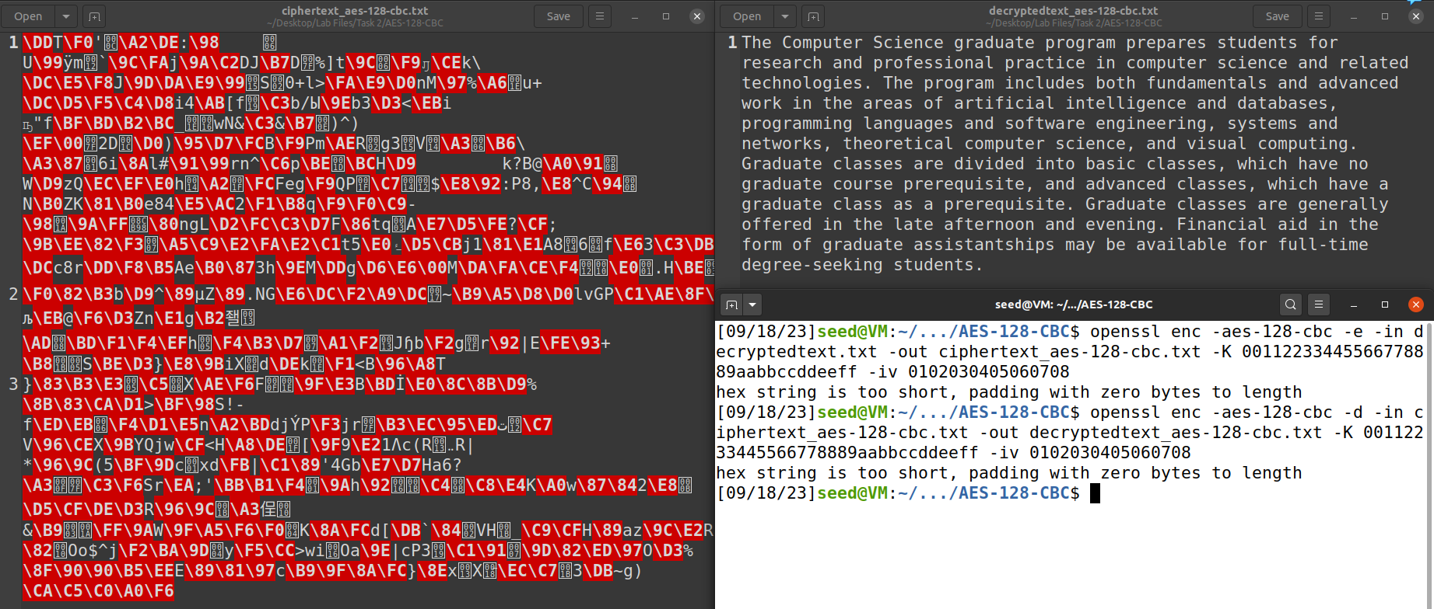

**Encryption 2: -BF-CBC**

*Encryption Command:*

openssl enc -bf-cbc -e -in decryptedtext.txt -out ciphertext_bf-cbc.txt -K 00112233445566778889aabbccddeeff -iv 0102030405060708

*Decryption Command:*

openssl enc -bf-cbc -d -in ciphertext_bf-cbc.txt -out decryptedtext_bf-cbc.txt -K 00112233445566778889aabbccddeeff -iv 0102030405060708

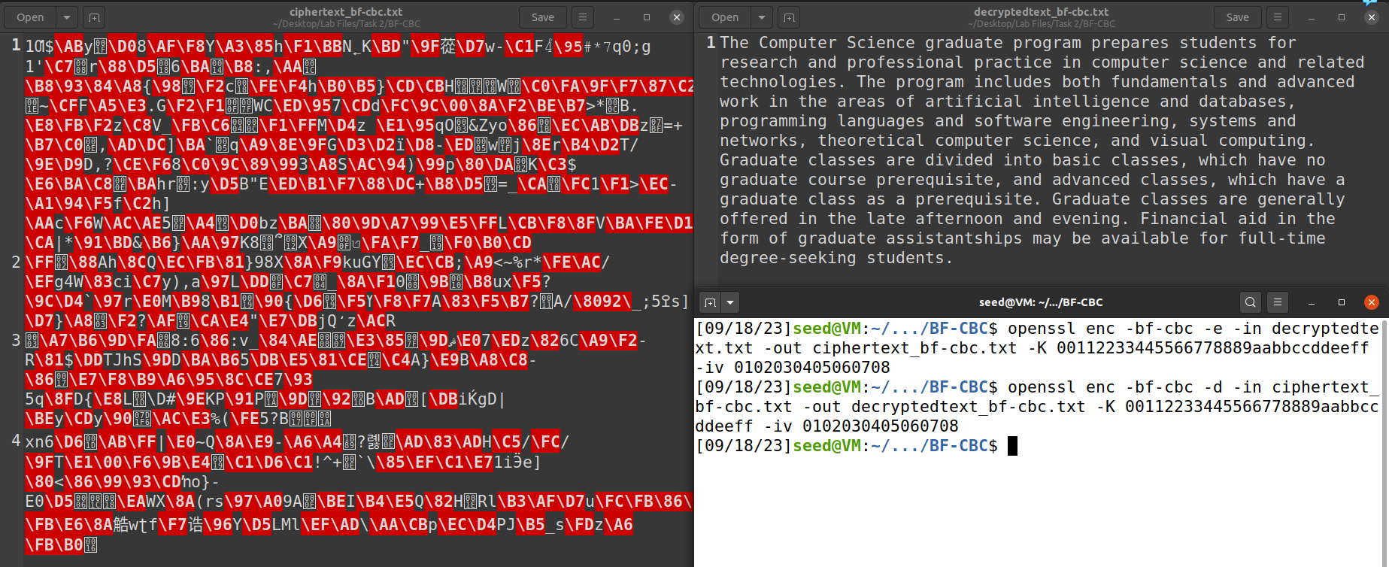

**Encryption 3: AES-128-CFB**

*Encryption Command:*

openssl enc -aes-128-cfb -e -in decryptedtext.txt -out ciphertext_aes-128-cfb.txt -K 00112233445566778889aabbccddeeff -iv 0102030405060708

*Decryption Command:*

openssl enc -aes-128-cfb -d -in ciphertext_aes-128-cfb.txt -out decryptedtext_aes-128-cfb.txt -K 00112233445566778889aabbccddeeff -iv 0102030405060708

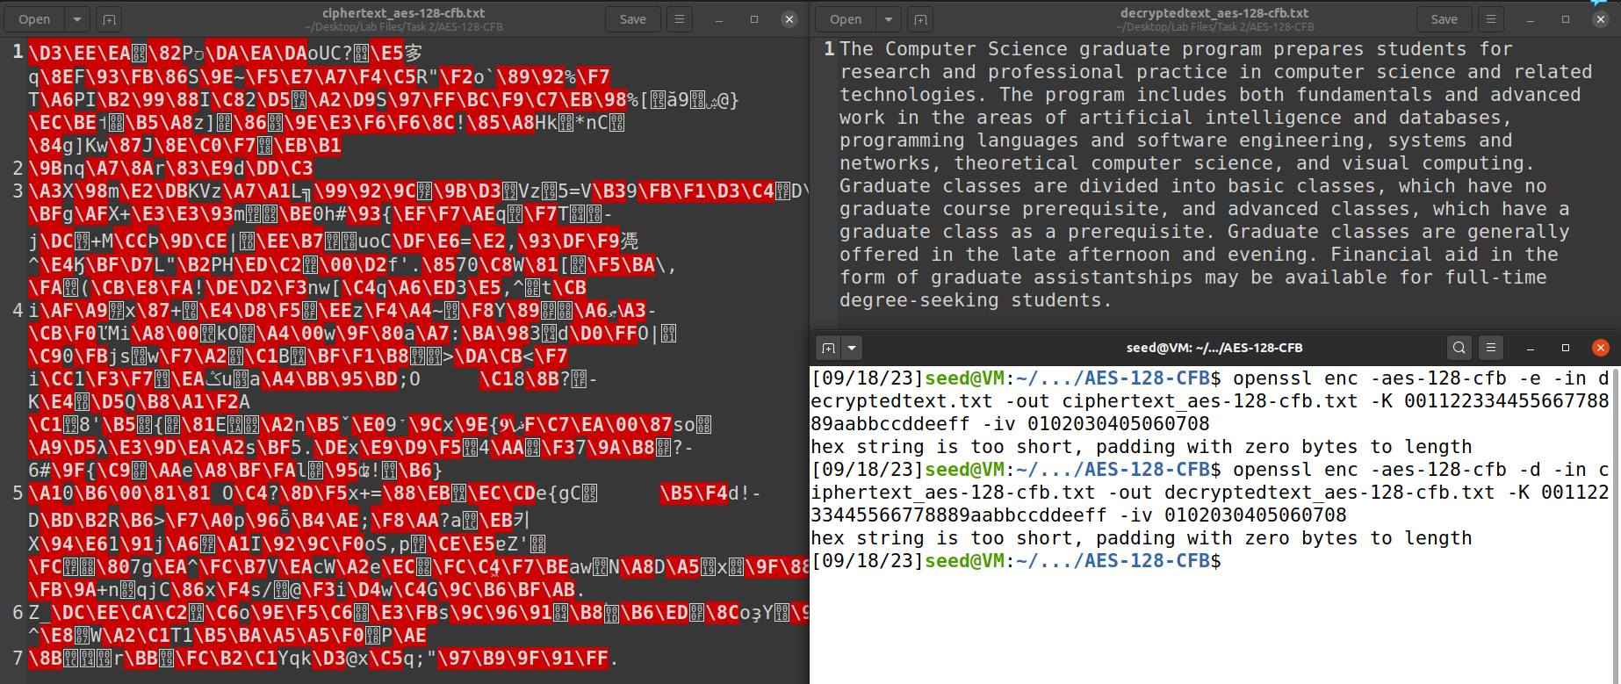

**Task 3: Encryption Mode – ECB vs. CBC**

*Picture 1:*

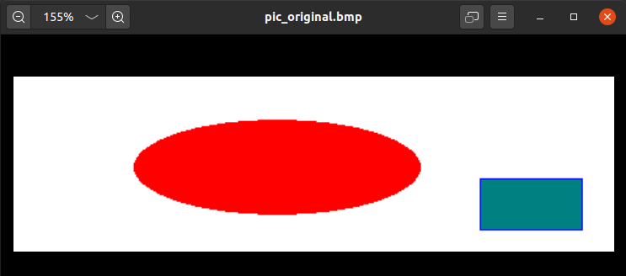

**ECB Mode Analysis:**

*Commands:*

openssl enc -aes-128-ecb -in pic_original.bmp -out encrypted_ecb.bmp

head -c 54 pic_original.bmp > header

tail -c +55 encrypted_ecb.bmp > body

cat header body > encrypted_ecb.bmp

*Terminal:*

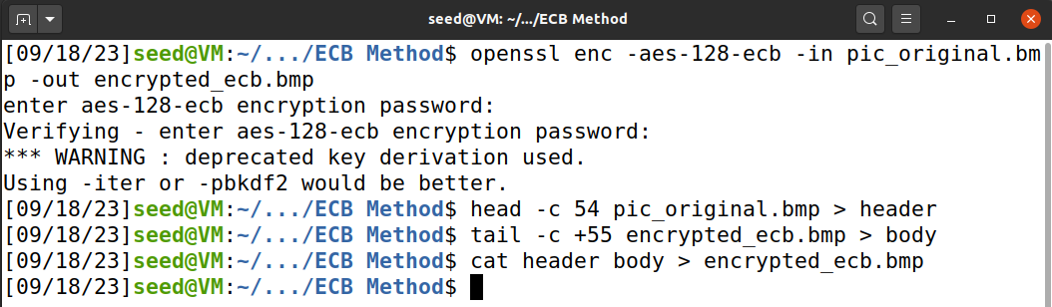

*Output:*

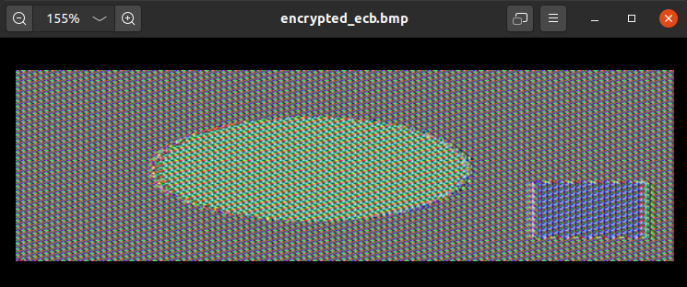

**CBC Mode Analysis:**

*Commands:*

openssl enc -aes-128-cbc -in pic_original.bmp -out encrypted_cbc.bmp

head -c 54 pic_original.bmp > header

tail -c +55 encrypted_cbc.bmp > body

cat header body > encrypted_cbc.bmp

*Terminal:*

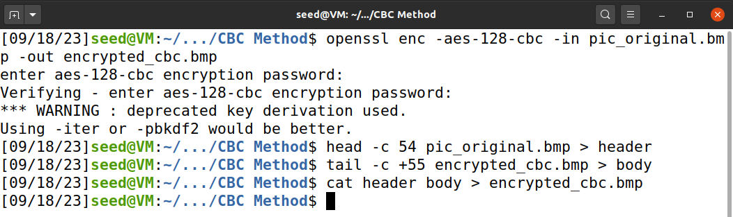

*Output:*

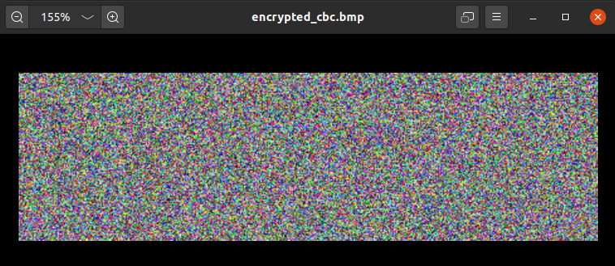

*Picture 2:*

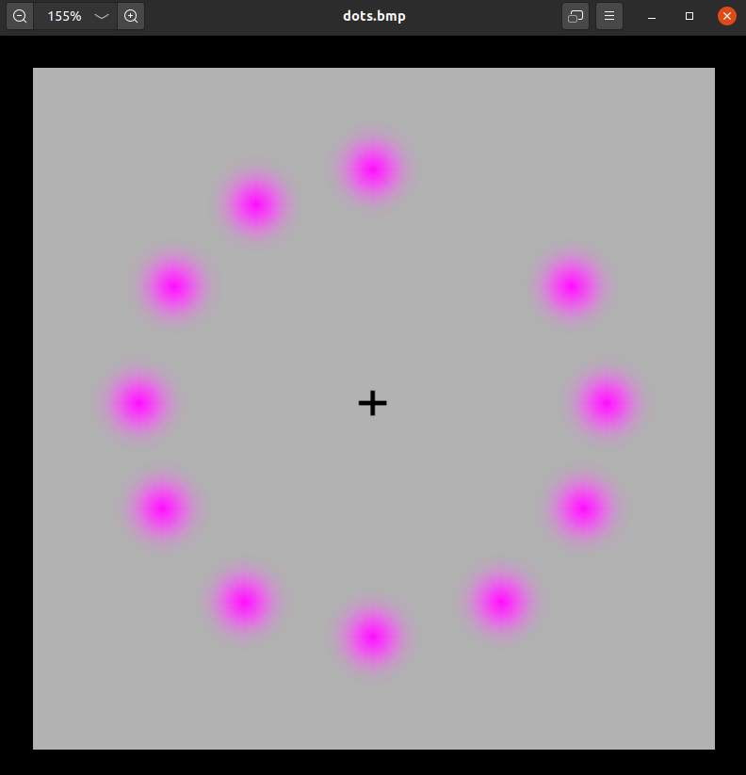

**ECB Mode Analysis:**

*Commands:*

openssl enc -aes-128-ecb -in dots.bmp -out encrypted_dots_ecb.bmp

head -c 54 dots.bmp > header

tail -c +55 encrypted_dots_ecb.bmp > body

cat header body > encrypted_dots_ecb.bmp

*Output:*

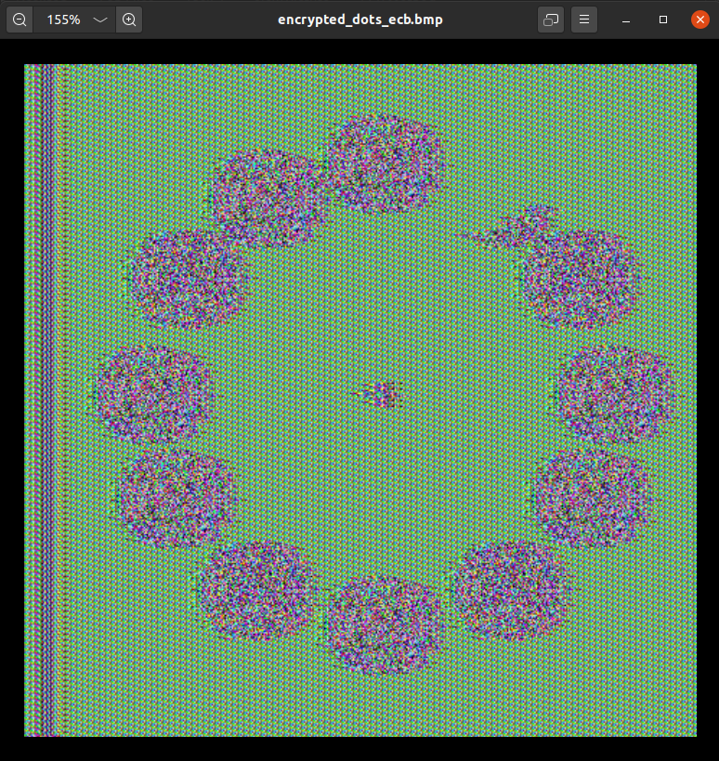

**CBC Mode Analysis:**

*Commands:*

openssl enc -aes-128-cbc -in dots.bmp -out encrypted_dots_cbc.bmp

head -c 54 dots.bmp > header

tail -c +55 encrypted_dots_cbc.bmp > body

cat header body > encrypted_dots_cbc.bmp

*Output:*  
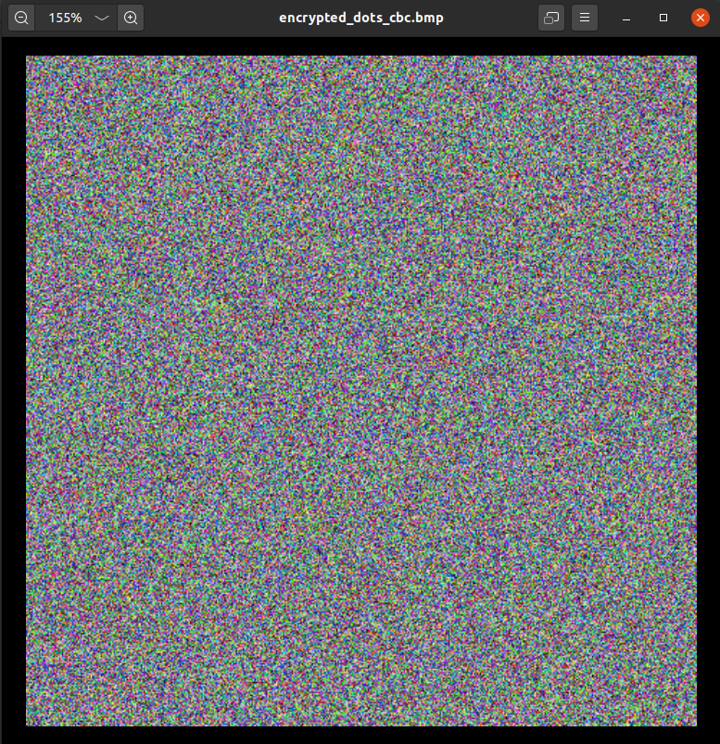

**Analysis:**

CBC mode enhances security by utilizing an Initialization Vector (IV) and encrypting data in fixed-size blocks, where each block's encryption depends on the previous one. This introduces diffusion, making it suitable for image encryption, as changes in the input result in complex transformations throughout the ciphertext. However, it requires padding for data that is not a multiple of the block size, and it is not well-suited for parallel processing due to block dependencies. CBC mode is chosen when security and preserving data patterns are priorities, making it an appropriate choice for image encryption, as it ensures that similar regions in the image do not have identical encrypted representations.

ECB mode divides data into fixed-size blocks and encrypts each block independently. While it offers simplicity and parallel processing advantages, it is not recommended for image encryption due to its vulnerability to identical plaintext blocks producing identical ciphertext. This lack of diffusion means that patterns in the image may still be discernible in the encrypted result, compromising security. As a result, ECB mode is typically avoided when encrypting images or data with structured patterns, as other modes like CBC or OFB are better suited to preserving security and confidentiality. It is important to choose the encryption mode carefully based on the specific application's requirements and the need for security and data integrity.

**Task 4: Padding**

We start by creating 3 files which contain 5 bytes, 10 bytes, and 16 bytes, respectively.

*Commands:*

echo -n "12345" > f1.txt

echo -n "1234567890" > f2.txt

echo -n "1234567890123456" > f3.txt

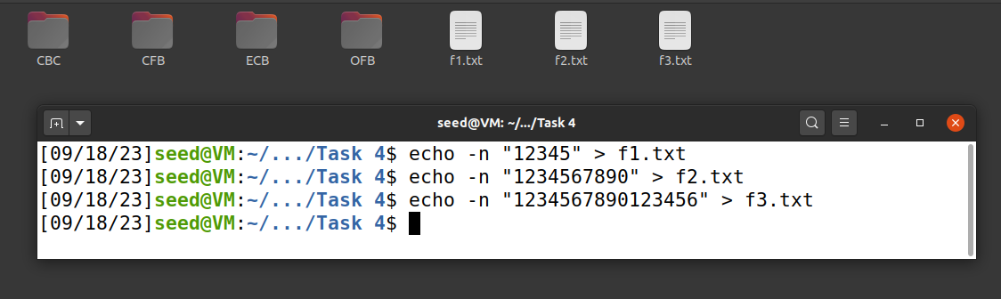

**Checking Padding For AES-128-CBC:**

*AES-128-CBC Encryption Commands:*

openssl enc -aes-128-cbc -e -in f1.txt -out encrypted_f1_cbc.txt

openssl enc -aes-128-cbc -e -in f2.txt -out encrypted_f2_cbc.txt

openssl enc -aes-128-cbc -e -in f3.txt -out encrypted_f3_cbc.txt

*AES-128-CBC Decryption Commands:*

openssl enc -aes-128-cbc -d -nopad -in encrypted_f1_cbc.txt -out decrypted_f1_cbc.txt

openssl enc -aes-128-cbc -d -nopad -in encrypted_f2_cbc.txt -out decrypted_f2_cbc.txt

openssl enc -aes-128-cbc -d -nopad -in encrypted_f3_cbc.txt -out decrypted_f3_cbc.txt

*Terminal:*

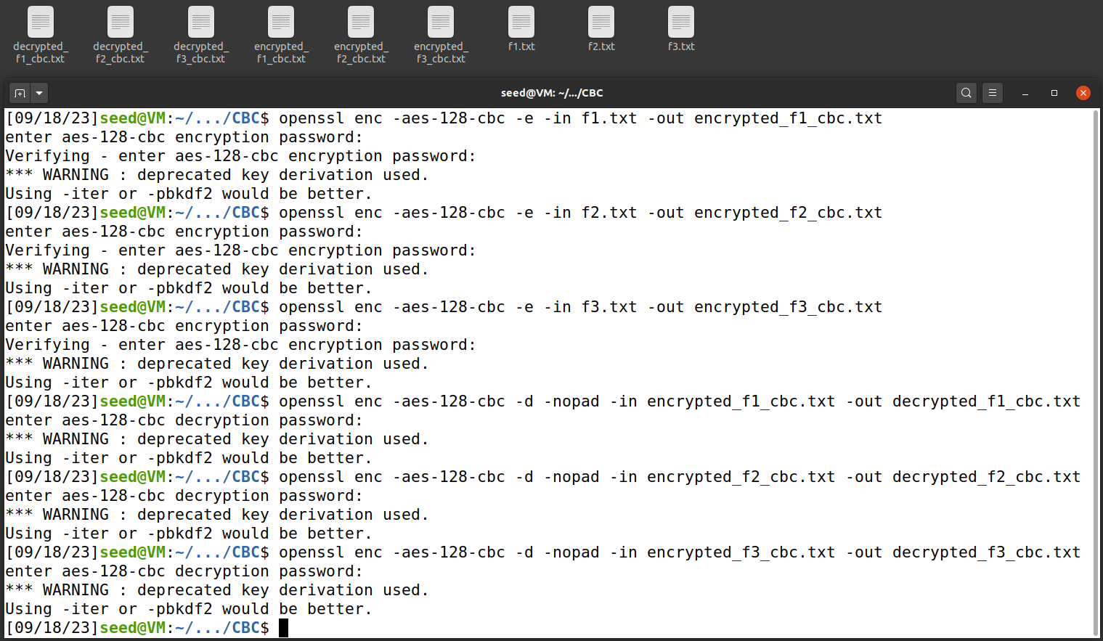

*File Sizes:*

encrypted_f1_cbc.txt – 32 bytes

encrypted_f2_cbc.txt – 32 bytes

encrypted_f3_cbc.txt – 48 bytes

*Padding Check:*

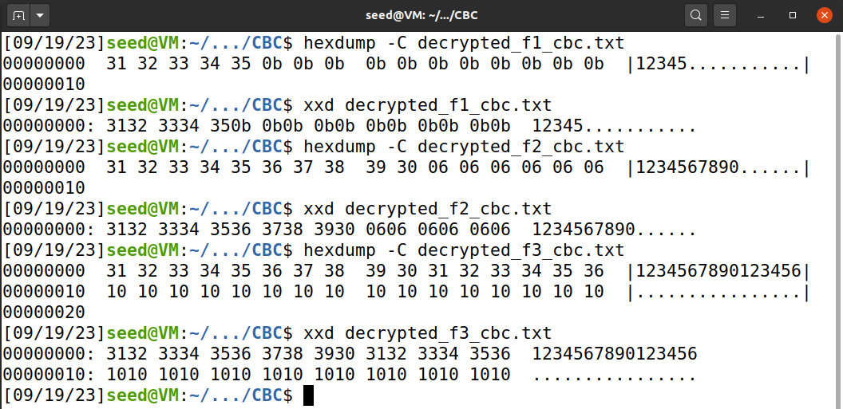

**Checking padding for AES-128-ECB:**

*AES-128-ECB Encryption:*

openssl enc -aes-128-ecb -e -in f1.txt -out encrypted_f1_ecb.txt

openssl enc -aes-128-ecb -e -in f2.txt -out encrypted_f2_ecb.txt

openssl enc -aes-128-ecb -e -in f3.txt -out encrypted_f3_ecb.txt

*AES-128-ECB Decryption:*

openssl enc -aes-128-ecb -d -nopad -in encrypted_f1_ecb.txt -out decrypted_f1_ecb.txt

openssl enc -aes-128-ecb -d -nopad -in encrypted_f2_ecb.txt -out decrypted_f2_ecb.txt

openssl enc -aes-128-ecb -d -nopad -in encrypted_f3_ecb.txt -out decrypted_f3_ecb.txt

*Terminal:*

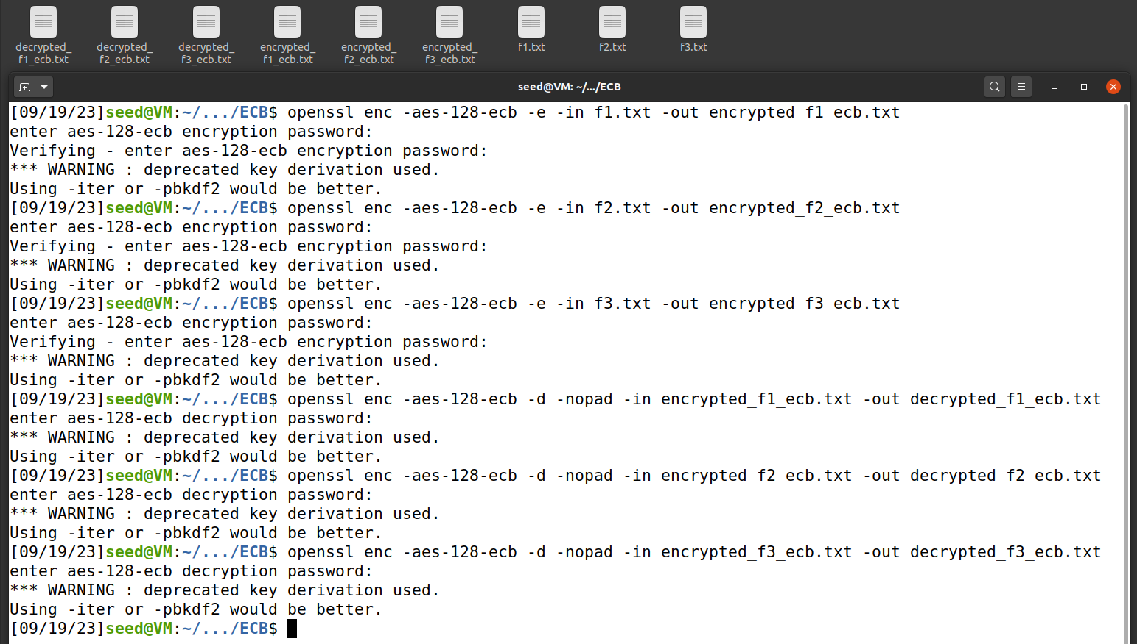

*File Sizes:*

encrypted_f1_ecb.txt – 32 bytes

encrypted_f2_ecb.txt – 32 bytes

encrypted_f3_ecb.txt – 48 bytes

*Padding Check:*

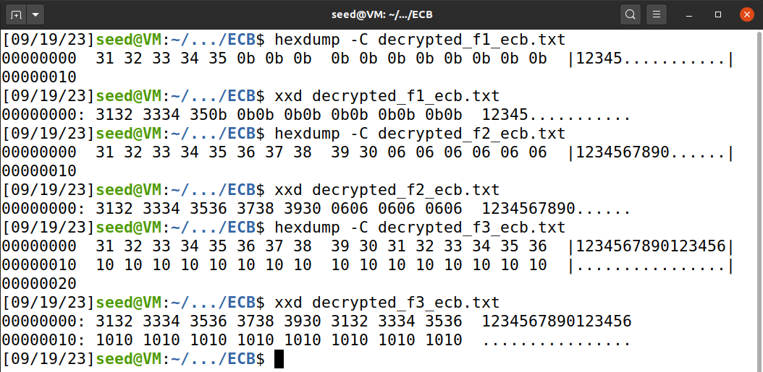

**Checking Padding For AES-128-CFB:**

*AES-128-CFB Encryption Commands:*

openssl enc -aes-128-cfb -e -in f1.txt -out encrypted_f1_cfb.txt

openssl enc -aes-128-cfb -e -in f2.txt -out encrypted_f2_cfb.txt

openssl enc -aes-128-cfb -e -in f3.txt -out encrypted_f3_cfb.txt

*AES-128-CFB Decryption Commands:*

openssl enc -aes-128-cfb -d -nopad -in encrypted_f1_cfb.txt -out decrypted_f1_cfb.txt

openssl enc -aes-128-cfb -d -nopad -in encrypted_f2_cfb.txt -out decrypted_f2_cfb.txt

openssl enc -aes-128-cfb -d -nopad -in encrypted_f3_cfb.txt -out decrypted_f3_cfb.txt

*Terminal:*

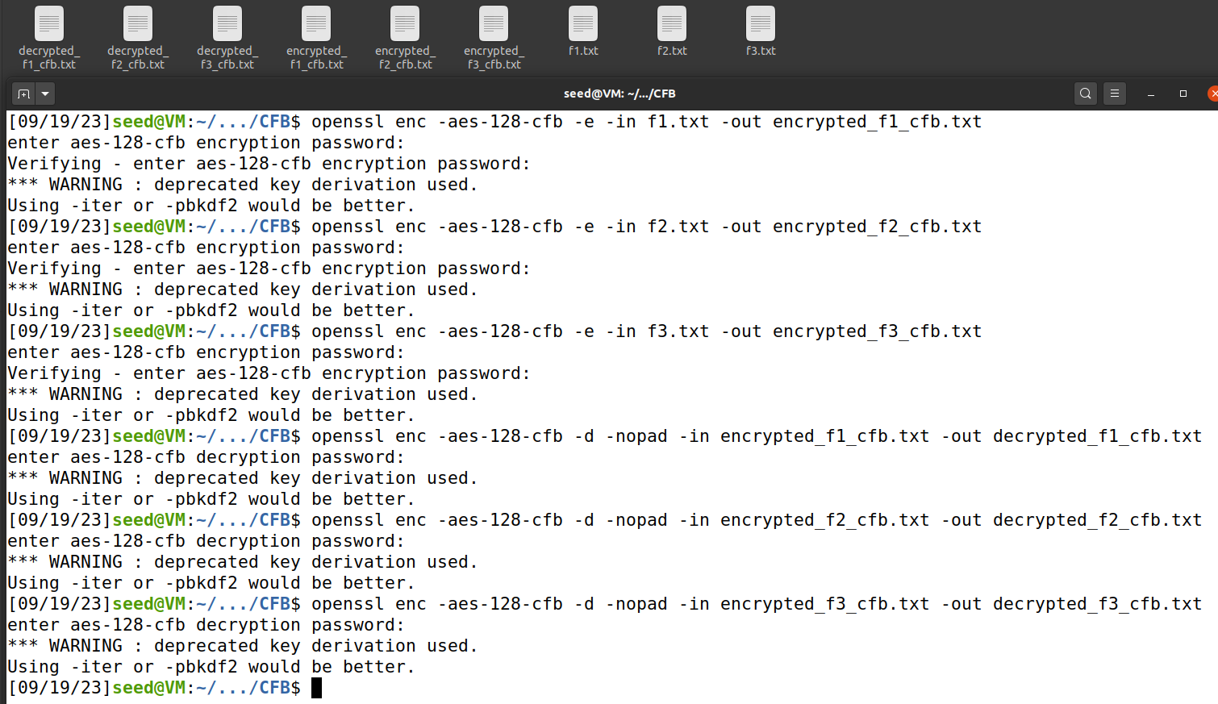

*File Sizes:*

encrypted_f1_cfb.txt – 21 bytes

encrypted_f2_cfb.txt – 26 bytes

encrypted_f3_cfb.txt – 32 bytes

*Padding Check:*

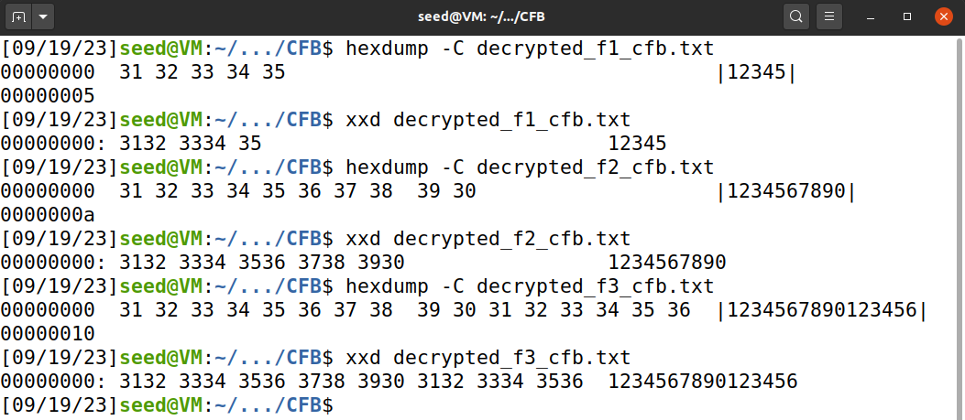

**Checking Padding For AES-128-OFB:**

*AES-128-OFB Encryption Commands:*

openssl enc -aes-128-ofb -e -in f1.txt -out encrypted_f1_ofb.txt

openssl enc -aes-128-ofb -e -in f2.txt -out encrypted_f2_ofb.txt

openssl enc -aes-128-ofb -e -in f3.txt -out encrypted_f3_ofb.txt

*AES-128-OFB Decryption Commands:*

openssl enc -aes-128-ofb -d -nopad -in encrypted_f1_ofb.txt -out decrypted_f1_ofb.txt

openssl enc -aes-128-ofb -d -nopad -in encrypted_f2_ofb.txt -out decrypted_f2_ofb.txt

openssl enc -aes-128-ofb -d -nopad -in encrypted_f3_ofb.txt -out decrypted_f3_ofb.txt

*Terminal:*

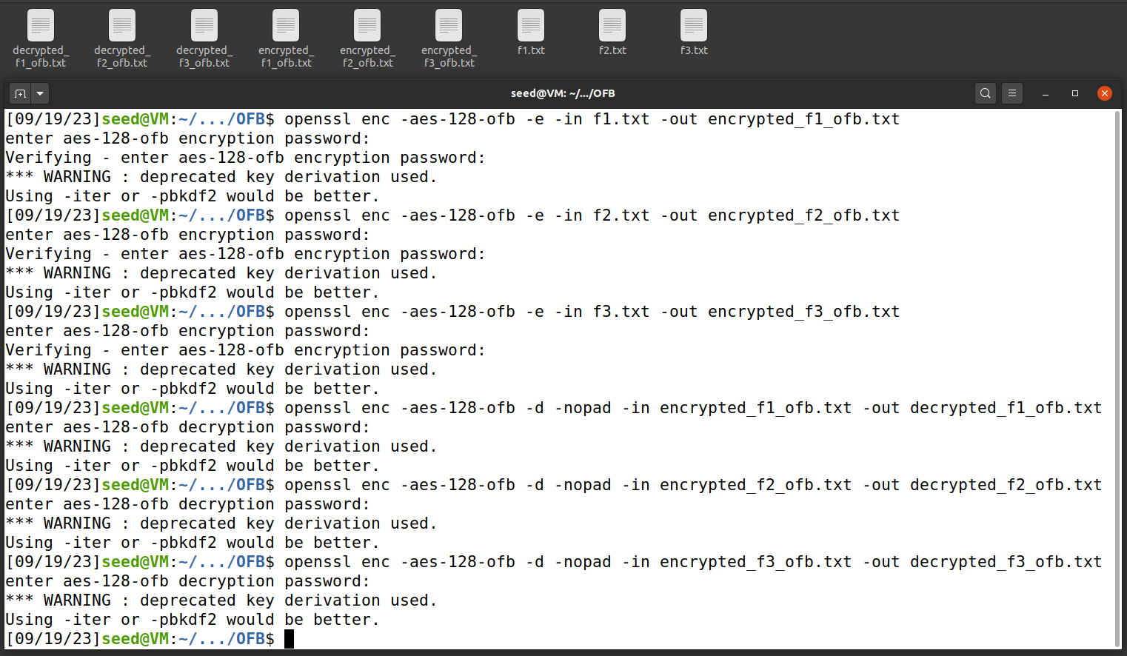

*File Sizes:*

encrypted_f1_ofb.txt – 21 bytes

encrypted_f2_ofb.txt – 26 bytes

encrypted_f3_ofb.txt – 32 bytes

*Padding Check:*

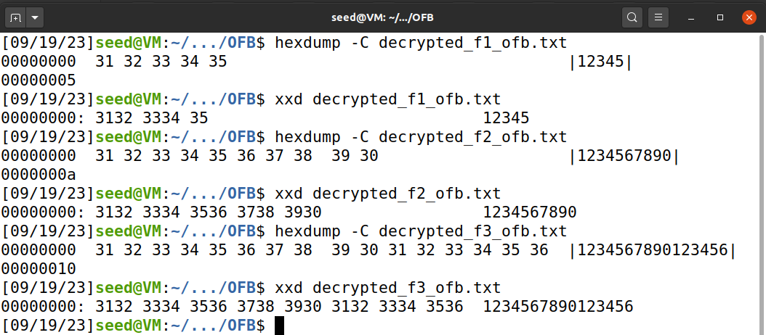

**Analysis:**

In conclusion, the choice of encryption mode impacts the display of text lengths when they do not align with the standard block size of 16 bytes used by CBC and ECB encryption. When the given text is 5 bytes long, both CBC and ECB append 11 bytes of padding, resulting in a display of 16 bytes with the additional bytes as 0 bits. Similarly, for a 10-byte given text, CBC and ECB append 6 bytes of padding, displaying 16 bytes with '06' appended. However, CFB and OFB modes, which do not require padding, maintain the same length as the given text. This is because CFB and OFB modes are especially used to convert block ciphers into stream ciphers that can handle input data of any size. Unlike ECB and CBC modes, they do not require a fixed block size. They simply generate a keystream equivalent to the length of the plain text, which can be used during encryption. In the case of a 16-byte given text, CBC and ECB append an extra 16 bytes of padding, displaying as 32 characters. Conversely, CFB and OFB modes display the same 16 bytes as the given text without any additional padding. These observations underscore the importance of choosing an encryption mode that aligns with the specific requirements of the data being encrypted.

**Task 5: Error Propagation – Corrupted Cipher Text**

The first step in this task is to create a new text file of 1000 bytes.

**ECB Mode Analysis:**

*ECB Mode Encryption Command:*

openssl enc -aes-128-ecb -in plaintext.txt -out encrypted_ecb.txt

*Terminal:*

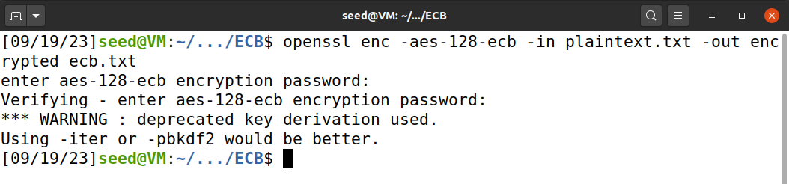

*Corrupting the File (Changed from B3 to B4) at the 55th Byte:*

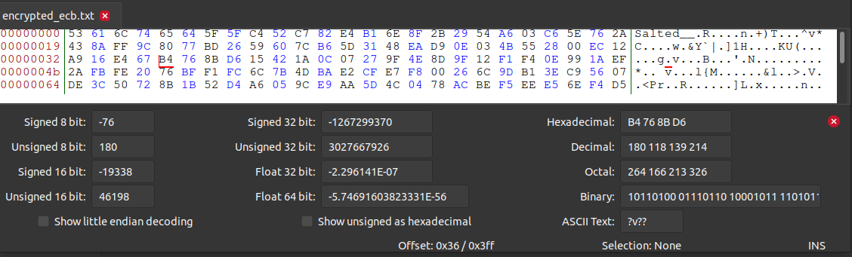

*ECB Mode Decryption Command:*

openssl enc -aes-128-ecb -d -in encrypted_ecb.txt -out decrypted_ecb.txt

*Output:*

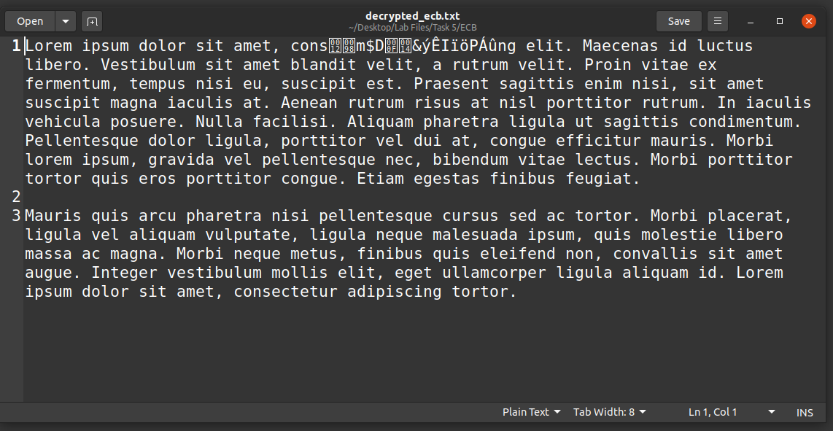

**CBC Mode Analysis:**

*CBC Mode Encryption Command:*

openssl enc -aes-128-cbc -in plaintext.txt -out encrypted_cbc.txt

*Terminal:*

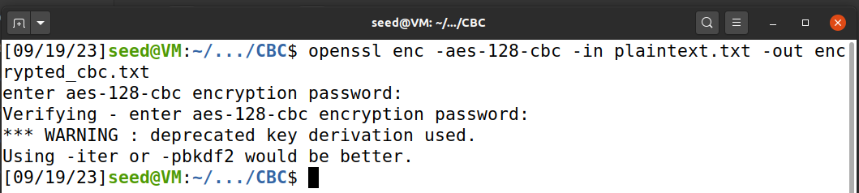

*Corrupting the File (C7 to C8) at the 55th Byte:*

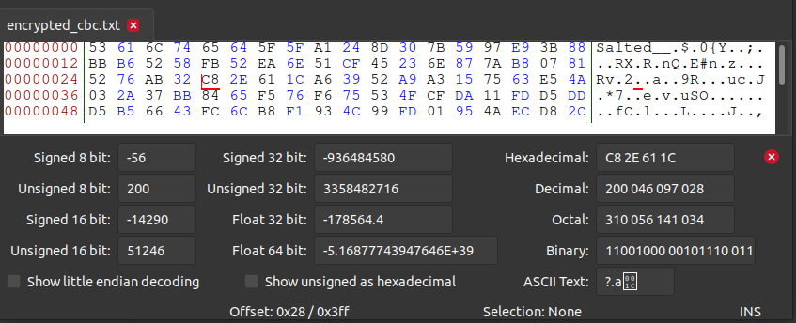

*CBC Mode Decryption Command:*

openssl enc -aes-128-cbc -d -in encrypted_cbc.txt -out decrypted_cbc.txt

*Terminal:*

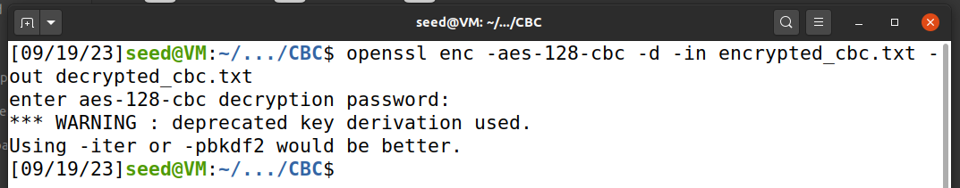

*Output:*

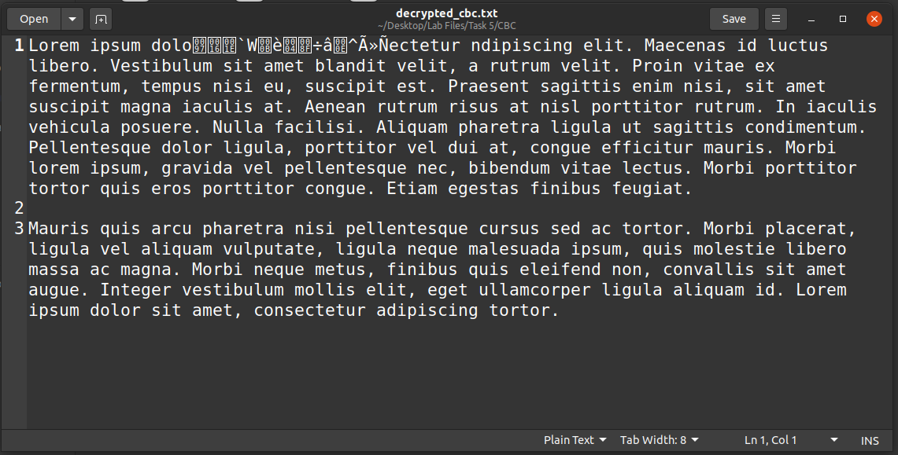

**CFB Mode Analysis:**

*CFB Mode Encryption Command:*

openssl enc -aes-128-cfb -in plaintext.txt -out encrypted_cfb.txt

*Terminal:*

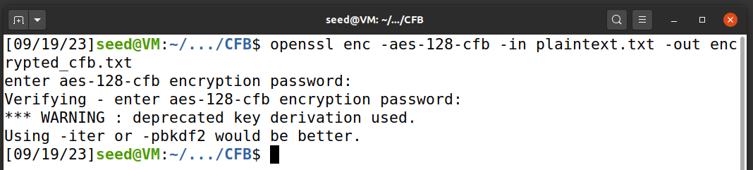

*Corrupting the File (5B to 5C) at the 55th Byte:*

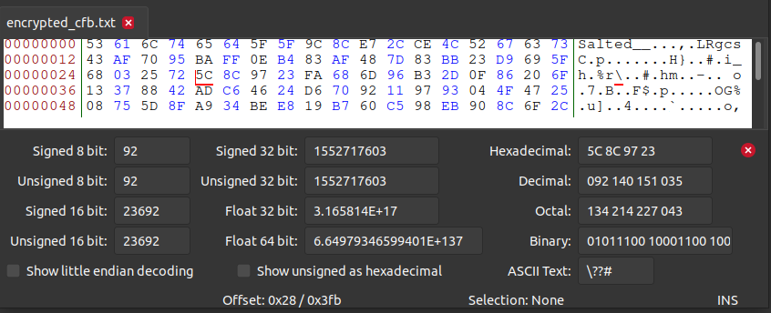

*CFB Mode Decryption:*

openssl enc -aes-128-cfb -d -in encrypted_cfb.txt -out decrypted_cfb.txt

*Terminal:*

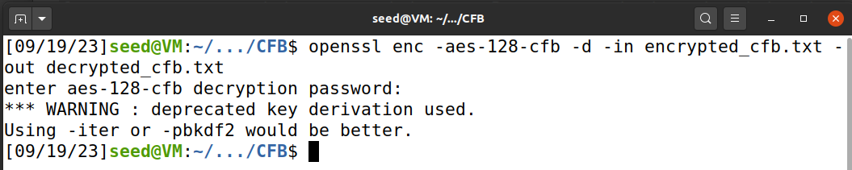

*Output:*

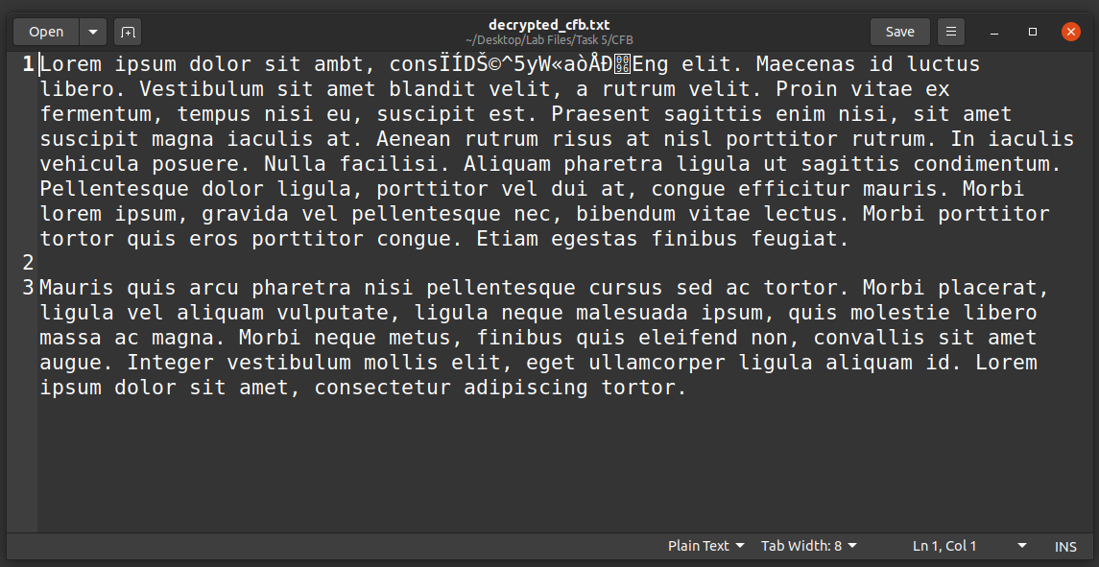

**OFB Mode Analysis:**

*OFB Mode Encryption Command:*

openssl enc -aes-128-ofb -in plaintext.txt -out encrypted_ofb.txt

*Terminal:*

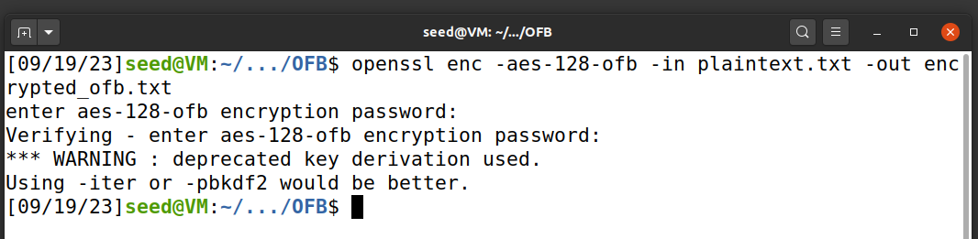

*Corrupting the file (31 to 32) at the 55th Byte:*

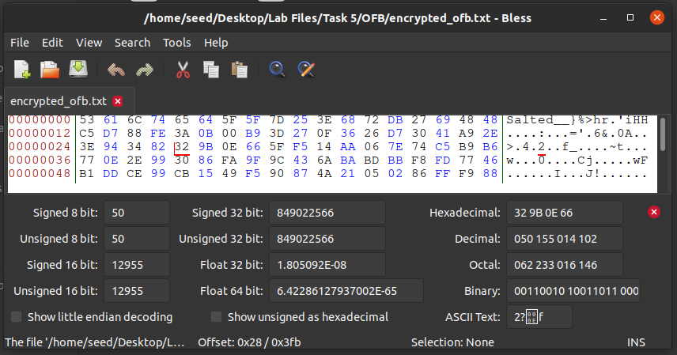

*OFB Mode Decryption Command:*

openssl enc -aes-128-ofb -d -in encrypted_ofb.txt -out decrypted_ofb.txt

*Terminal:*

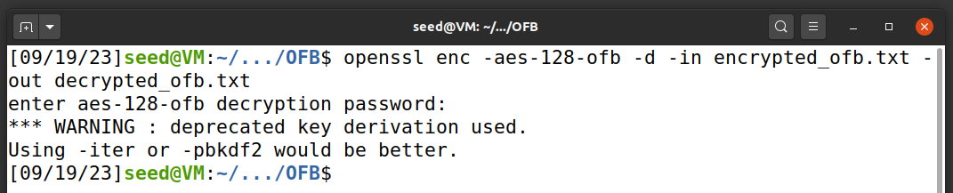

*Output:*

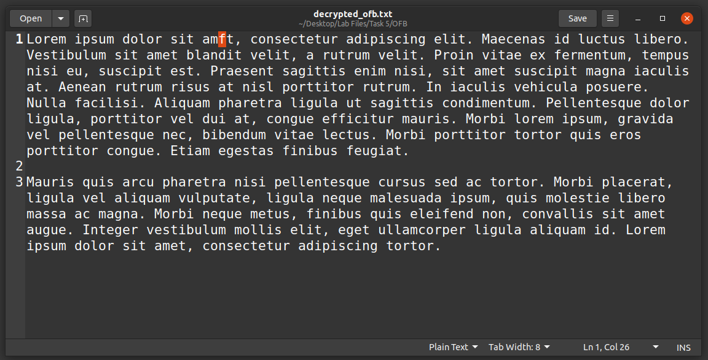

**Analysis:**

In ECB mode, cipher text issues are confined to individual blocks. Since decryption is performed block by block, any flaw in an 8-byte cipher text block may affect all bits in the corresponding 8-byte plaintext block. ECB mode is generally considered unsuitable for deployment due to several reasons. Identical data blocks are transformed into identical cipher blocks during encryption, making it easy to spot repeated data. Attackers can manipulate the order of encrypted blocks without detection. While this mode is recognized as flawed and no longer recommended, it is primarily used for encrypting data smaller than a single block.

In CBC mode, since each decrypted plain text block depends on its own cipher block as well as its previous cipher block, Error propagates through both the blocks. That is, a corrupted cipher block affects the corresponding plain text block as well as the following plain text block. All the other blocks remain safe, since they are not dependent on that cipher block during decryption.

CFB mode typically involves n/r blocks, where an error in one block affects several other blocks. That is, the error in a ciphertext bit will affect the corresponding decrypted plain text block as well as the corresponding bit in the keystream (shift register) for that block. This affects subsequent plain text blocks since they depend on the keystream generated from previous ciphertext blocks. This mode is considered secure against CPA (Chosen-Plaintext Attack).

OFB mode is relatively resilient to errors. Changing a single digit within a byte only impacts that specific character in the plain text. Errors in one block have no influence on other blocks. To maintain security in this mode, the encryption key is changed every 2n/2 block, where n represents the number of bits in a block. However, it should be avoided as it offers no protection against CCA (Chosen-Ciphertext Attack) threats.